Sequence Diagram (For connection)

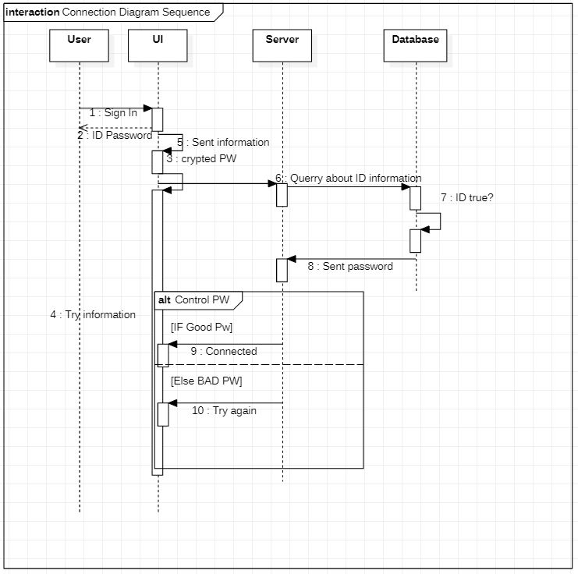

We have created this diagram to see how different object collaborate.

For the apps there are four object who playing together, and we will see how they are working and what is different links between them.

The first actor is the user: it’s them who will use the application and he will interact with UI (User interface). UI is the main element in the apps because he will show the information (like message, profile …). But UI doesn’t work alone he need to relate to server to get information who is stored in database. The typical way of connection:

Step 1:

User Sign-in with ID and Password. UI will return/ show information On the screen.

Step 2:

UI will crypt information in local and sent information to the Server.

Step 3:

Server will check on database ID and PW:

Step 4:

Server will return 2 possibilities:

First: if data is good UI will return Ok and will connect user on personal apps.

Second: SIf wrong data UI will return false “Try again”.